Technical Development Program for
Process Performance Engineers

Clinker Uniformity
Case Study
Part A
Objective and General Plant Situation

Version 05 Nov 2015
LafargeHolcim Ltd.
Cement Industrial Performance
Quality Management and Optimization

Situation and Objective

General situation and objective
Plant TH is producing clinker with a strongly varying composition. Kiln operation is considered to suffer from this variability. The situation was addressed previously (investigation 2001) and various improvements have been made. However, in the year 2006, the situation is not yet satisfactory. A new attempt has to be made to review and improve the situation.

Quality data underlining the high variability can be seen in Annex A.1

As a Process Engineer you have the task to investigate the reasons for this variability and to suggest short and medium-term measures to enable production of a significantly more uniform clinker.

Main plant features:
A simplified plant layout is given in Annex A.2.

Raw components:
Material | Source | Comments | Avg. use in raw mix  [%] | Moisture  [%]
CR Limestone | Own, but external quarry, transported by barges on the sea |  | 81.3 | 10.8
Vulcan Limestone | External supplier, transported by barges | Used in small quantities, sweetener, | 3.6 | 8.9
Fly ash | Various sources |  | 9.6
Sand | Natural, wet |  | 2.7 | 8.4
Iron correctives |  |  | 0.5
Various alternative raw materials |  |  | 2.3

Raw material extraction:
Limestone: extraction from quarry ponds with drag line

Raw material preparation (at plant)
Stockpiles
- Limestone: Longitudinal stockpiles, side reclaimer
- Sand, iron correctives: on stockpiles, reclaim by trucks
- Fly ash: silos

Drying
- 2 rotary dryers for limestone and sand (alternatingly)
- Hot air from kiln, always passing the dryers
- Bag filter after dryers (dust of dryer + kiln dust)

Raw component storage/ feed silos
- 8 (6 main, 2 interstitial)

Raw meal preparation
8 Feed silos (7 in use)
Grinding system (240 t/h, BDP 320 t/h) consisting of
- 1 roller press
- 1 ball mill
4 Continuous blending silos; 4 x 5000 t

Average raw mix see table above.

Clinker production
Fuel

 | Coal | TDF* | Gas | Petcoke | On-spec waste oil
Energy cons.  (avg year) [%] | 76.1 | 10.4 | 2.6 | 9.2 | 1.1
Preparation | Coal mill |  |  | Coal mill
Feed location | BZ & PC | PC | BZ & PC | BZ & PC | BZ
Ash [%] | 11.3 | 4.8 | -- | 0.4 | --
*: Tire derived fuel

Coal mill: 23.3 t/h (coal and petcoke co-grinding)

Clinker
Kiln: PC4, 4774 t/d (BDP 4841 t/d), heat consumption 3316 MJ/t

Task A
- Comment the extent of material variability and any additional observations with regard to raw meal, kiln feed and clinker analyses

- Comment on:
- Plant areas that you want to investigate in more detail
- Specific information you would like to get concerning each of the above areas

Annex A.1: Materials variability

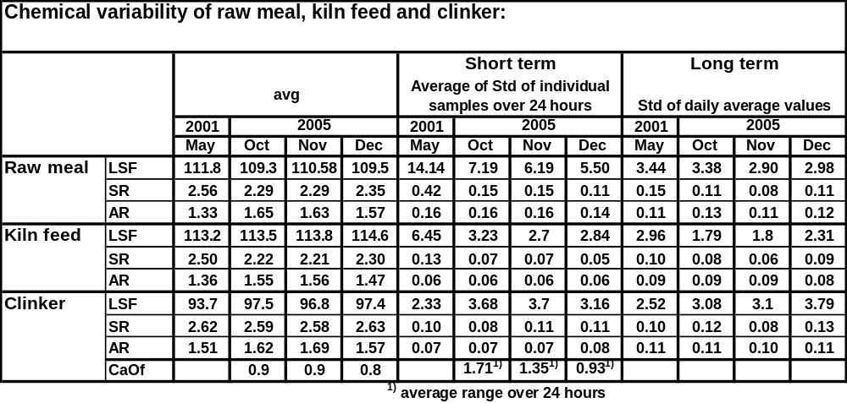

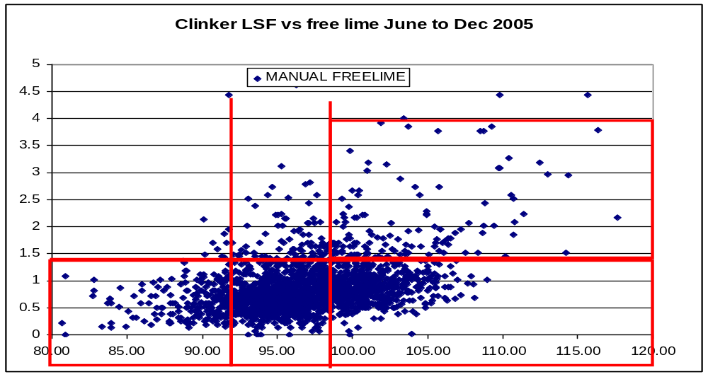

Annex A.2: Simplified layout

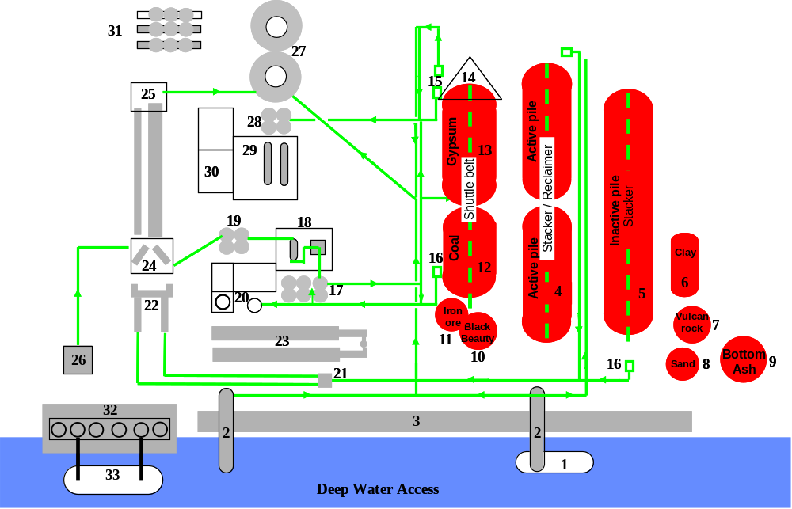

Legend

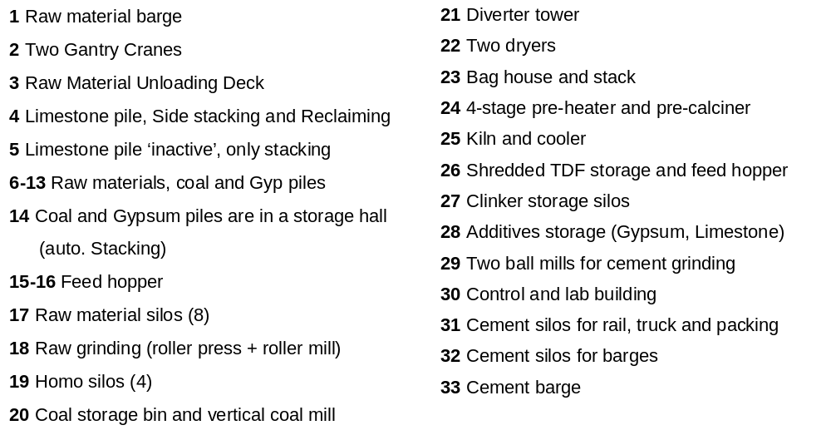
Active Pile (LS):
Side stacker, side reclaimer

Inactive Pile (LS):
Side stacker front end-loader reclaiming

